**Personal Assistance for Seniors Who Are Self-Reliant**

**Assignment – II**

**Topic :** PYTHON CODE TO GET TEMPERATURE AND HUMIDITY VALUE

**Name:** REVATHI M

**Register Number:** 921019104042

**E-Mail Id :** [srirevathi670@gmail.com](mailto:srirevathi670@gmail.com)

**Code:**

import random

while(True):

temp=random.randint(10,99)

humid=random.randint(10,99)

print("current temperature: ",temp)

print("current humidity:",humid,"%")

temp_ref=35

humid_ref=50

if temp > temp_ref and humid < humid_ref:

print("Alarm On")

else:

print("Alarm off")

break

**OUTPUT**

**ALARM OFF**

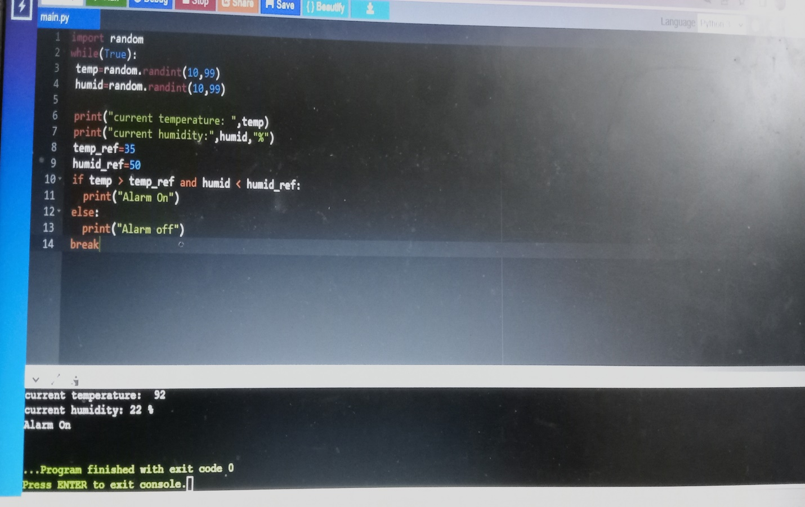

**ALARM ON**

